Question Bank for Viva
- J2EE architecture( all four containers and components)
Applet is a special type of program that is embedded in the webpage to generate the dynamic content. It runs inside the browser and works at client side.
- JDBC four drivers

1) JDBC-ODBC bridge driver
The JDBC-ODBC bridge driver uses ODBC driver to connect to the database. The JDBC-ODBC bridge driver converts JDBC method calls into the ODBC function calls. This is now discouraged because of thin driver.

2) Native-API driver
The Native API driver uses the client-side libraries of the database. The driver converts JDBC method calls into native calls of the database API. It is not written entirely in java.

3) Network Protocol driver
The Network Protocol driver uses middleware (application server) that converts JDBC calls directly or indirectly into the vendor-specific database protocol. It is fully written in java.

4) Thin driver
The thin driver converts JDBC calls directly into the vendor-specific database protocol. That is why it is known as thin driver. It is fully written in Java language.

- JDBC required packages and exceptions
java.sql
javax.sql
JDBC Exception handling is very similar to the Java Exception handling but for JDBC, the most common exception you'll deal with is java.sql.SQLException.
Exceptions that occur due to the Database or Driver come under SQL Exception.
- Preparedstatement interface and method
The PreparedStatement interface is a subinterface of Statement. It is used to execute parameterized query.Let's see the example of parameterized query:
String sql="insert into emp values(?,?,?)";
As you can see, we are passing parameter (?) for the values. Its value will be set by calling the setter methods of PreparedStatement.

- Statement interface
The Statement interface provides methods to execute queries with the database. The statement interface is a factory of ResultSet i.e. it provides factory method to get the object of ResultSet.
- DriverManager interface
The DriverManager class acts as an interface between user and drivers. It keeps track of the drivers that are available and handles establishing a connection between a database and the appropriate driver. The DriverManager class maintains a list of Driver classes that have registered themselves by calling the method DriverManager.registerDriver().
- getConnection method
it's a method in the Drivermanager class, is used to establish the connection with the specified url, username and password.
- createStatement method and its parameters
createStatement returns a statement object, it doesn't have any parameters.
- execute() and executeQuery() method
execute method can run both select and insert/update statements.
executeQuery method execute statements that returns a result set by fetching some data from the database. It executes only select statements.
executeUpdate method execute sql statements that insert/update/delete data at the database.

- Servlet Architecture / lifecycle
Lifecycle:
1.Load and instantiate (call the init() method for servlet initialization)
2.Process the request(service() method is called for processing the request(logic part), handle multiple requests ..n number of requests and responses)
3.When web container decides to destroy the servlet instance, After the destroy() method is executed, the Servlet container releases all the references of this Servlet instance so that it becomes eligible for garbage collection.
The entire life cycle of a Servlet is managed by the Servlet container which uses the javax.servlet.Servlet interface to understand the Servlet object and manage it. So, before creating a Servlet object, let’s first understand the life cycle of the Servlet object which is actually understanding how the Servlet container manages the Servlet object.
- Why servlet in place of CGI
CGI: for every request a process is created, this will affect the performance when the process /request load is increased.
Servlet: for every request a thread is created, therefore better performance
- Servlet packages
- Types of servlets
Generic Servlet
- Protocol independent. It can handle all types of protocols like http, ftp, smtp.
- Class is direct subclass of servlet interface.
- It is an abstract class which implements servlet, servlet config interfaces.
- Contains service method.
- implements servlet config and way to accept initialization param passed to servlet from xml.
Http Servlet
- Protocol dependent supports only http.
- Direct subclass of generic servlet.
- It is an abstract class which extends generic servlet and implements java.io.serializable
- uses doGet, doPost and doDelete methods
- Public void service and protected void service.

- Servletconfig, servletcontext and requestdispatcher interfaces
ServletConfig is one per servlet. ServletContext is one per web app.
ServletConfig is configuration information for a single Servlet/JSP page. ServletContext provides context (background information) to the servlet. It gives information about the web application.
Because of this, ServletContext can facilitate setting and getting attributes between servlets and provide generic functionality like access to request dispatcher.
The RequestDispatcher interface provides the facility of dispatching the request to another resource it may be html, servlet or jsp. This interface can also be used to include the content of another resource also. It is one of the way of servlet collaboration.

- Services provided by servlet container
- Advantages of using a servlet
- Servlet provide better performance that CGI in terms of processing time, memory utilization because servlets uses benefits of multithreading and for each request a new thread is created, that is faster than loading creating new Object for each request with CGI.
- Servlet is platform and system independent, the web application developed with Servlet can be run on any standard web container such as Tomcat, JBoss, Glassfish servers and on operating systems such as Windows, Linux, Unix, Solaris, Mac etc.
- Servlets are robust because container takes care of life cycle of servlet and we don?t need to worry about memory leaks, security, garbage collection etc.
- Servlets are easy to maintain and scalable.
- Use of session in servlet
- Use of cookies in servlet
- Exceptions used in servlets
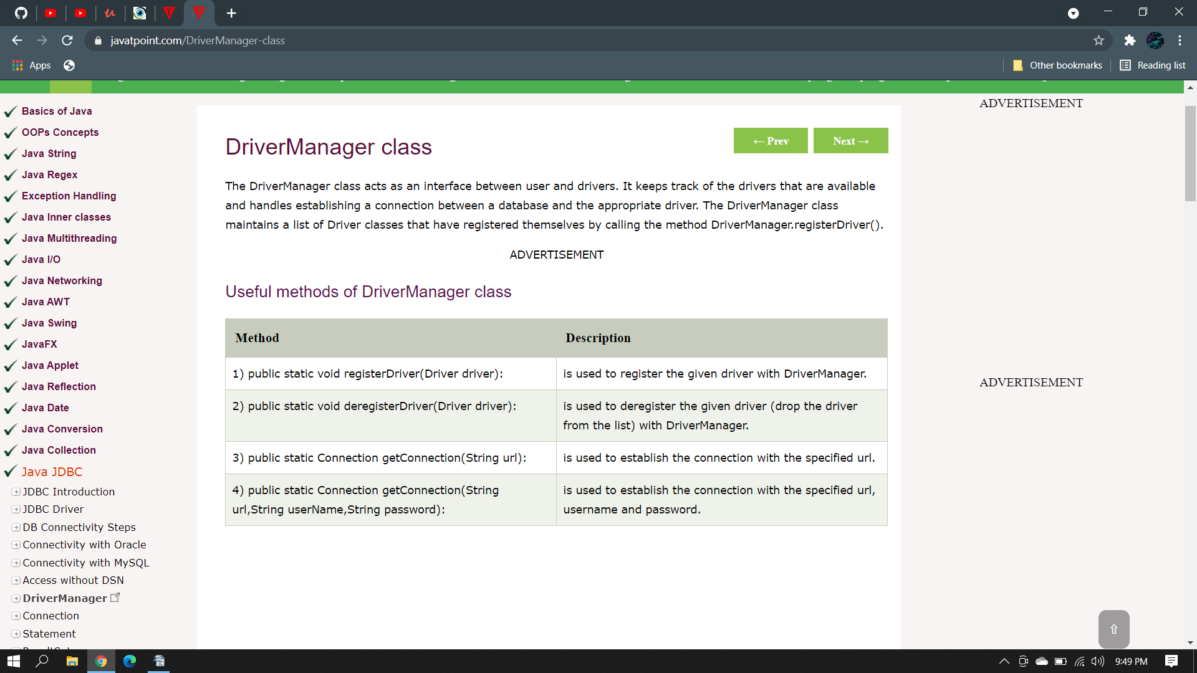
- doGet() and doPost() methods

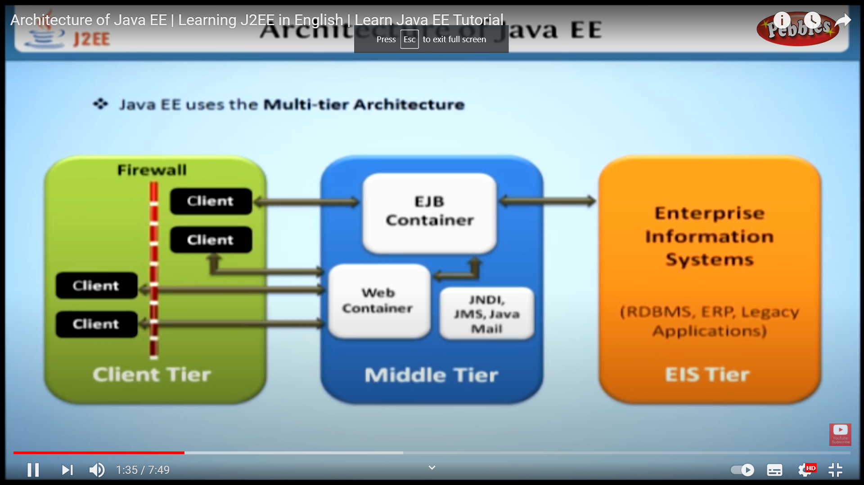
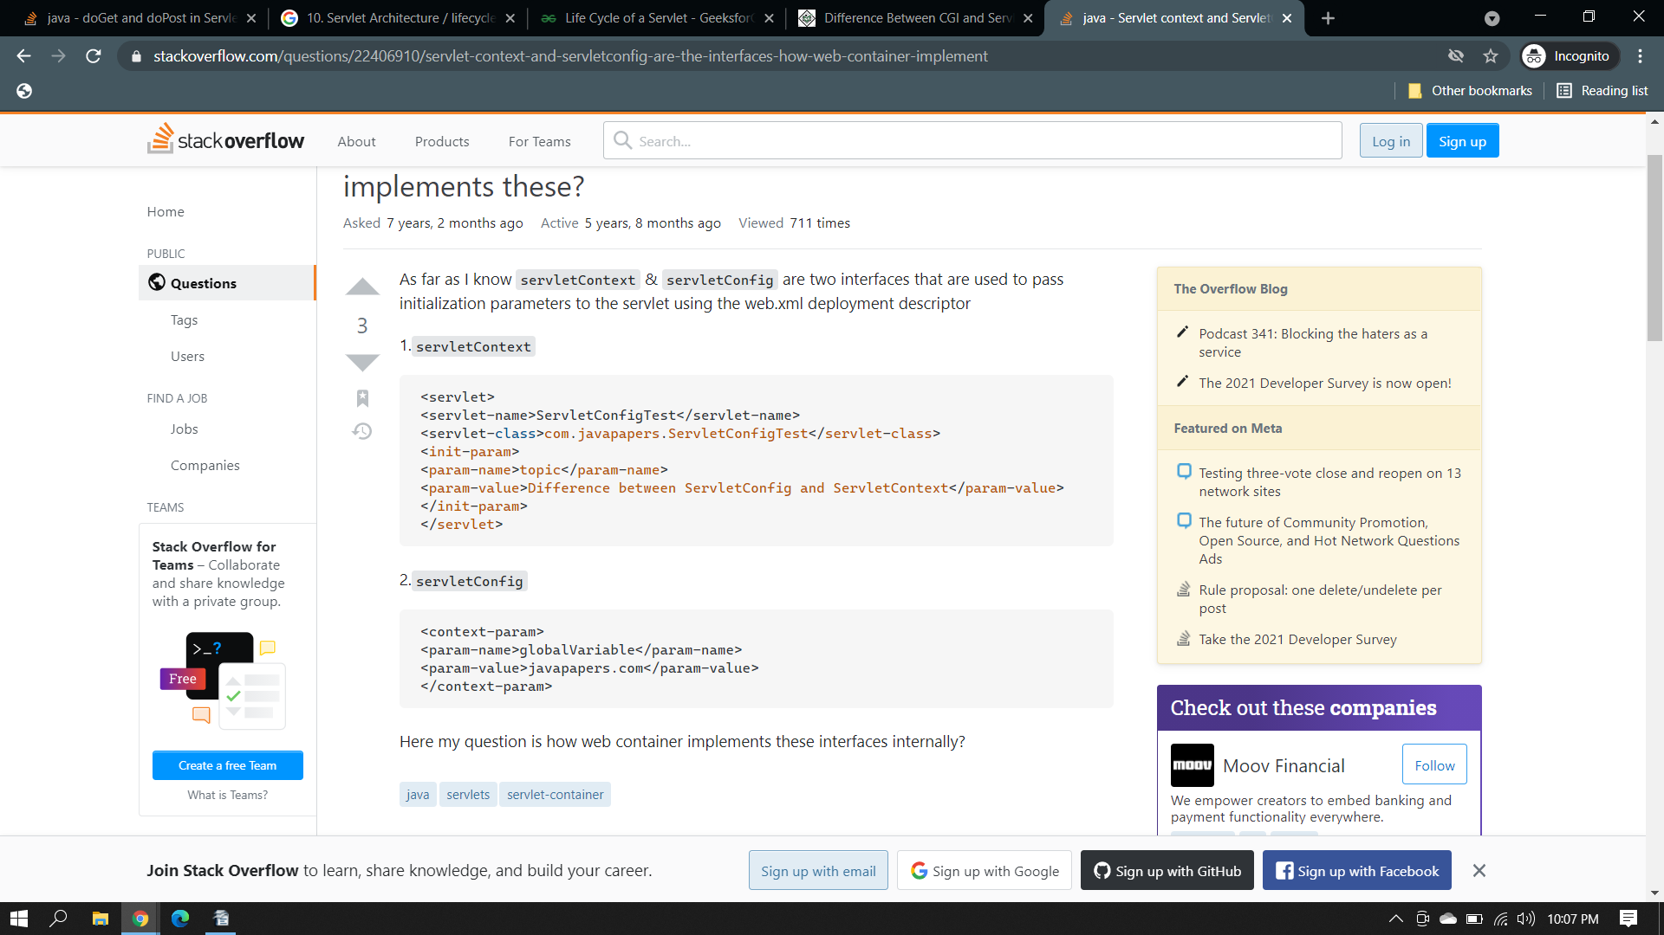
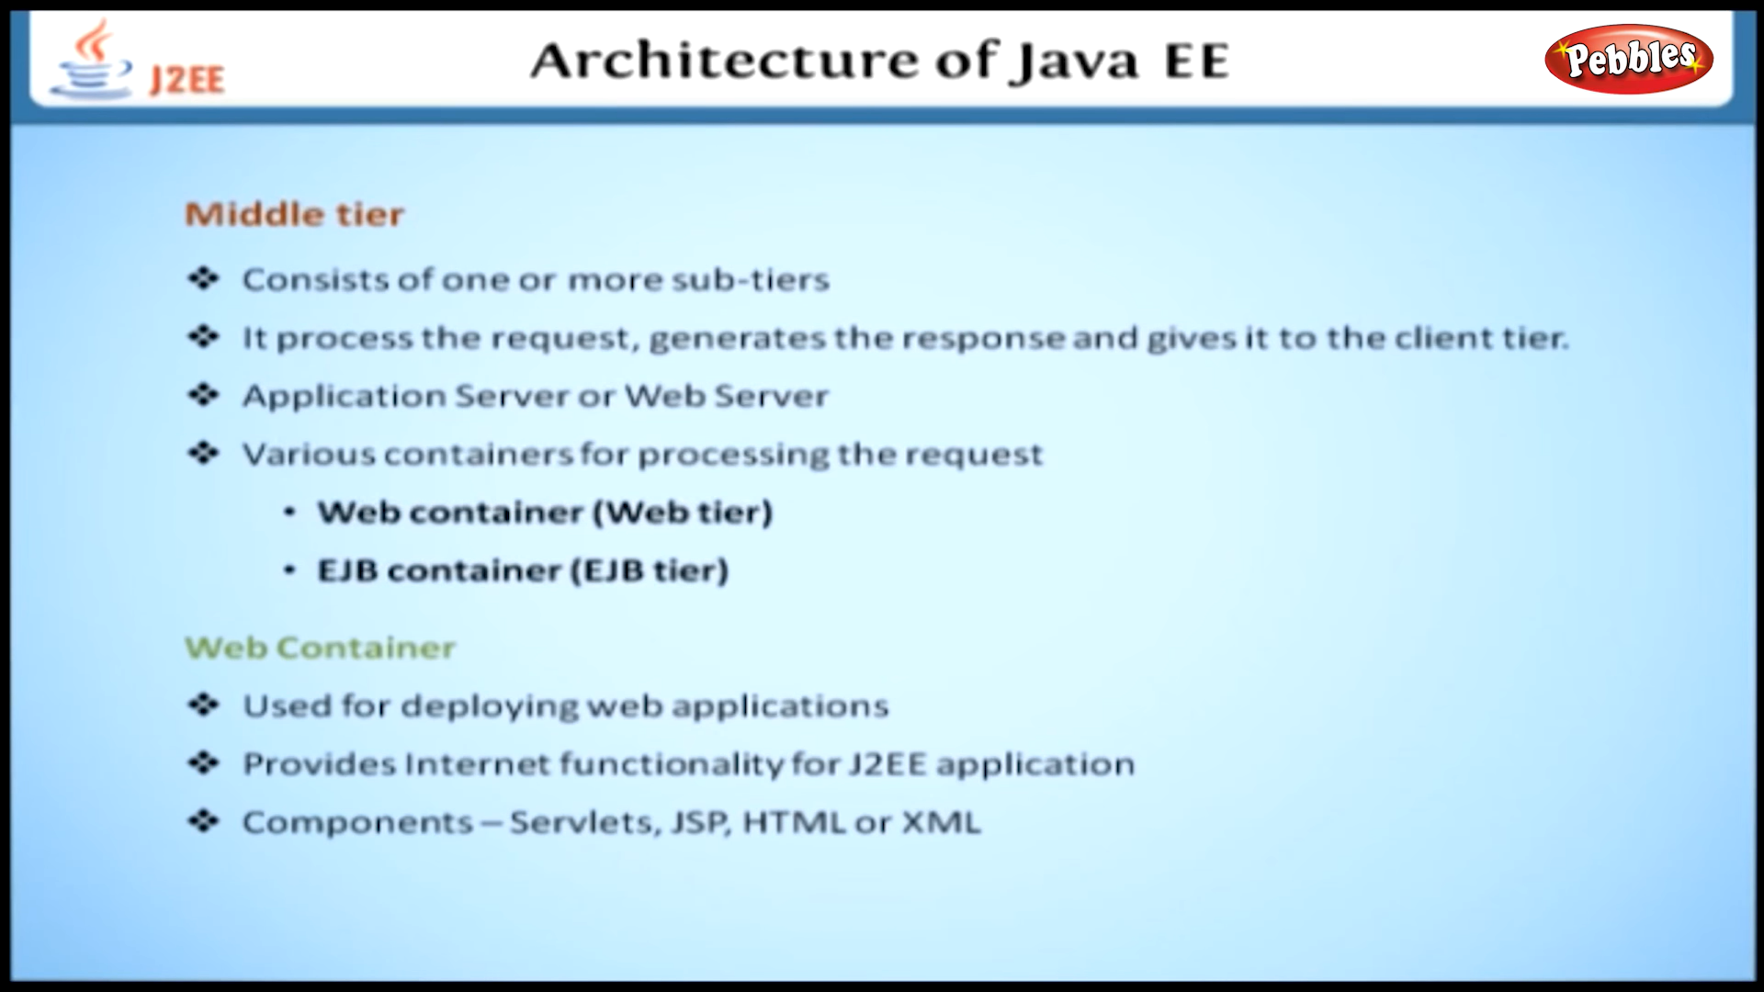
Containers provide the runtime support for J2EE application components. Containers provide a federated view of the underlying J2EE APIs to the application components. J2EE application components never interact directly with other J2EE application components. They use the protocols and methods of the container for interacting with each other and with platform services. Interposing a container between the application components and the J2EE services allows the container to transparently inject the services defined by the components’ deployment descriptors, such as declarative transaction management, security checks, resource pooling, and state management.
